



ITIL Demand Management Process
Standard Practices Document



GAVS Technologies N.A., Inc
116 Village Blvd, Suite 200, Princeton,
New Jersey 08540, USA.
http://www.gavstech.com/



Document Version
Document Revision Number | 2.1
Effective Date | 13-Jan-23
Owner | GAVS Quality Team
Modified by | Gouri Mahendru
Approved by
Document Revision History
Version No. | Release date | Summary of changes | Prepared by | Approved by
1.0 | 17-Apr-20 | Initial Document | Gouri Mahendru | Sekar T
2.0 | 3-Jan-23 | Spelling corrections and alignment changes | Premalatha G
2.1 | 13-Jan-23 | Updated section A-9, E-1 | Gouri Mahendru

Table of Contents
Section A: Introduction 5
1. Overview 5
2. Definition 5
3. Process Objective 6
4. Scope 6
5. Benefits 7
6. Triggers, Inputs and Outputs 7
7. Key Terms 7
8. Demand Management and Service Lifecycle 9
9. Demand Planning 9
9.1. Difference between Demand Planning and Forecasting 10
9.2. Demand Planning Cycle 10
9.3. Elements of Demand Planning Process 11
9.4. Demand Planning Tools 12
9.5. Demand Planning Methods 12
10. Demand and Capacity Management 12
11. Demand types and classification 13
Section B: Process Flow 15
1. Demand Management Process Flow 15
1.1. Demand Prognosis 15
1.2. Process Activities of Demand Management 16
Section C: Roles and Responsibilities 20
1. User Roles and Functions 20
2. RACI Matrix 21
Section D: Governance and Process Controls 22
1. CSF and KPI 22
2. Inter-relationships with other ITIL processes 23
2.1. Service Portfolio Management 23
2.2. Service Catalogue Management 23
2.3. Service Desk 23
2.4. Continual Service Improvement 24
Section E: Appendix 25
1. References 25

Table of Figures
Figure 1: Demand activities 5
Figure 2: Demand planning cycle 10
Figure 3: Demand Management process 15
Figure 4: Capacity management takes note of Demand management 18
Figure 5: Demand pipeline approach 19
Figure 6: Demand management inter-relationship with other processes 23

Section A: Introduction
- Overview
The following Demand Management Process has been designed for the GAVS IT Service Management program. It will be used as a reference for the implementation and use of the Demand Management process on an ongoing basis. This process document is based on the best practices described in the Information Technology Infrastructure Library (ITIL®) Framework.
It includes Demand Management goals, objectives, scope, policies, key terms, roles, responsibilities, authority, process diagrams and associated activity descriptions. This Process will have relationships with other Processes and those documents should be read and understood along with this, the primary related processes being Strategy, Service Portfolio, Financial, Business Relationship, Service Level, Capacity, Availability, IT Service Continuity, Change, Service Asset & Configuration, Service Validation & Testing, and Event Management Process.
- Definition
ITIL® defines Demand as the buyer’s willingness and ability to pay a price for a specific quantity of a good or service; the relationship between price and quantity demanded is known as the demand.
Demand Management is the process responsible for the activities that understand and influence customer demand for services and the provision of capacity to meet these demands.
Demand management works with capacity management to ensure that the service provider has enough capacity to meet the required demand. At a strategic level, demand management can involve analysis of patterns of business activity and user profiles, while at a tactical level, it can involve the use of differential charging to encourage customers to use IT services at less busy times, or require short-term activities to respond to unexpected demand or the failure of a configuration item.
The main purpose of demand management process is to Analyze, Anticipate and Influence the demand by the customers for services and the process by which adequate capacity to satisfy the demand is provisioned.
This involves the following actions:
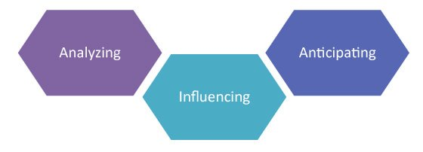
Figure 1: Demand activities
- Analyzing the present usage of IT services by customers
The simplest way to analyze the current customer usage is to analyze the service desk data which contains details of incidents, requests, and problems.
- Anticipating the future demands for IT services by customers
The business relationship manager plays a role in anticipating the future demands for IT services by the customers. The manager may speak with the customer directly regarding the needs which have been predicted, analyze trends in usage and make educated projections regarding usage of the service in the future based on similar customer trends.
- Influencing the consumption of services as required by technical or financial means
It is the duty of demand management to make sure that the appropriate costs are included in the service design. For example, if a customer makes use of more than anticipated amount of service as per the Service Level Agreements, then the service provider can charge an additional fee to offset the costs of the unexpected demand.
- Process Objective
The primary objective of the Demand Management process is to understand, anticipate and influence customer demand for services and to work with capacity management to ensure the service provider can meet this demand.
Demand management works at every stage of the lifecycle to ensure that services are designed, tested, and delivered to support the achievement of business outcomes at the appropriate levels of activity.
This is where the service provider can understand the customer needs and feed these into the service strategies to realize the service potential of the customer and to differentiate the services to the customers.
The objectives for the Demand Management process are to:
- Identify and analyze patterns of business activity to understand the levels of demand that will be placed on a service
- Define and analyze user profiles to understand the typical profiles of demand for services from different types of user
- Ensure that services are designed to meet the patterns of business activity and the ability to meet business outcomes
- Work with capacity management to ensure that adequate resources are available at the appropriate levels of capacity to meet the demand for services, thus maintaining a balance between the cost of service and the value that it achieves
- Anticipate and prevent or manage situations where demand for a service exceeds the capacity to deliver it
- Gear the utilization of resources that deliver services to meet the fluctuating levels of demand for those services
- Scope
The scope of the demand management process is to identify and analyze the patterns of business activity that initiate the demand for services and to identify and analyze how different types of user influence the demand for services.
Demand management activities should include:
- Identifying and analyzing patterns of business activity associated with services
- Identifying user profiles and analyzing their service usage patterns
- Identifying, agreeing, and implementing measures to influence demand together with capacity management

- Benefits
Employing Demand management may involve a radical re-do for all business units involved, but its benefits are measurable:
- Achieve a balance between the cost of service and the value of the business outcomes it supports - The other service strategy processes define the linkage between business outcomes, services, resources, and capabilities
- Refines the understanding of how, when and to what level these elements interact - This enables executives to evaluate the real investment required to achieve business outcomes at varying levels of activity
- Triggers, Inputs and Outputs
Triggers
- A request from a customer for a new service or change to an existing service. This will be initiated through business relationship management and service portfolio management.
- A new service is being created to meet a strategic initiative – this will be initiated through service portfolio management.
- A service model needs to be defined, and patterns of business activity and/or user profiles must be defined.
- Utilization rates are causing potential performance issues or a potential breach of an SLA.
- An exception has occurred to forecast patterns of business activity
Inputs
- Initiative to create a new service, or to change an existing service. These inputs can come from service portfolio management or from change management.
- Service models need to be validated, and patterns of business activity associated with each service model will need to be defined.
- The customer portfolio, service portfolio, and customer agreement portfolio, all of which will contain information about demand and supply for services.
- Charging models will be assessed to ensure that under- or over-recovery does not occur in internal service providers, or that pricing will be profitable for external service providers.
- Chargeable items will need to be validated to ensure that customers perceive them and use them as defined.
- Service improvement opportunities and plans will need to be assessed regarding their impact on demand
Outputs
- User profiles
- Patterns of business activity will be formally documented and included in the service and customer portfolios
- Policies for management of demand when resources are over-utilized
- Policies for how to deal with situations where service utilization is higher or lower than anticipated by the customer
- Documentation of options for differentiated the offerings that can be used to create service packages
- Key Terms
- Portfolio - A collection of demands managed as a group to achieve strategic and operational objectives.
- Assessable record - A demand record that you want to evaluate for metric type demand. You evaluate the assessable records with metric categories and metrics, which define traits and values to assess.
- Metric - A trait or value used to evaluate assessable records. A metric can measure subjective values in an assessment questionnaire or gather objective values in a database query run by a script. Examples of metrics include perceived value of demands and return on investment for a demand.
- Metric type - A characteristic that defines a set of records you want to evaluate. Demand management comes with the metric type demand, which uses records from the Demand table.
- Metric category - A theme for evaluating assessable records. Categories contain one or more individual metrics, which define specific traits or values that comprise the theme. Examples of categories include return on investment and cost. Set filter conditions to control which assessable records to evaluate for the metrics in a category.
- Stakeholder - A person affected by the demand or who has interest in the demand.
- Scorecard - A visual breakdown on performance of an assessable record based on assessment results. Use scorecards to view various data summaries for one assessable record and to compare the ratings with other assessable records.
- Requirement - An extra item that must be present or an extra action item that must be finished before a demand request closes.
- Demand Task - A unit of work, created within a demand, to break down initial planning activities before converting the demand into a project. A demand task is not a planned task like a project task.
- Supply and demand - Consumption produces demand and production consumes demand in a highly synchronized pattern. This demand and supply cycle will function effectively only while the service assets have capacity available.
A significant part of demand management is to understand the potential demand and the impact of the demand on the service assets.
- Gearing Service Assets - The balance between demand and supply can be achieved by gearing the service assets to meet the dynamic patterns of on-demand services. This is done by responding to demand as it occurs and anticipating the demand by identifying the signals of increasing or decreasing demand.
A mechanism should be defined to scale investment and supply as and when required. Managing service assets as per demand variations involves several actions by service management:
  - Identifying the services in question through service portfolio management.
  - Quantifying the pattern of business activity
  - Mentioning specifically the appropriate type of architecture to deal with the type and quantity of demand.
  - Capacity and availability are planning to make sure that the assets of the right service are available at the right time and are performing at the right levels as per requirement.
  - Performance management and tuning of service assets to deal with demand variations.
- Demand Management and Service Lifecycle
Demand management is a critical aspect of service management. Poorly managed demand is a source of risk for service providers while excess capacity generates cost without creating value that provides a basis for cost recovery.
Service production cannot happen without the simultaneous presence of demand that consumes the output. It is a pull system in which consumption cycle stimulates production cycle. Demand pulls capacity. Demand cannot exist simply because capacity exists.
Consider the following points for Demand management through lifecycle:
- Forecast demand and communicate to design and Support SPM
- Confirm service assets are designed to meet capacity and availability requirements
- Testing and validating services for forecast utilization and PBA
- Technical, application, and operations management functions will monitor services to ensure demand is within normal levels
- Identify trends in PBA and to initiate changes in capabilities of provider/customers
There could be situations where service demand exceeds capacity, and where capacity increases are not feasible (e.g., differential charging, incentives, penalties). It could also be in situations where a new service has been launched, and IT wishes to encourage users to use it more. This is sometimes called the ‘management of demand.’
Also, it could be used to reduce demand in peak utilization times and shift it to fewer active times – thus more efficiently balancing overall utilization levels. Demand management is active in every stage of the service lifecycle and works closely with several other processes.
- It should not be assumed that the process which is active at each stage of the lifecycle will address the issues related to demand.
- If demand management is not coordinated and managed on a regular basis, it will happen only on a reactive basis.
- Demand Planning
Demand Planning is a multi-step and iterative operational Supply Chain Management process, which generates reliable demand forecasts based on historical sales data and relevant business information like – impact of marketing promotions, new product launches and discontinuations, pricing discounts, rebates, and market intelligence.
Normally, there are multiple Demand Planners that contribute to the Demand Planning process. And there are remotely located individual Demand Planners for specific product categories, geographical regions, and customer segmentation. Different inputs from these Demand Planners contribute to the overall Demand Planning process. Hence, for global businesses, it is imperative that their Demand Planning process is fundamentally collaborative.
Key benefits of building a collaborative Demand Planning process include:
- Increased processing speed and accuracy
- Reduction in forecast errors
- Increase in customer service levels
- Reduction in bull-whip effect across the Supply Chain
- Cost savings
- Increased productivity
- Transparent data sharing for a better decision-making process

Difference between Demand Planning and Forecasting
Demand Planning and Demand Forecasting are two different terms which are often used interchangeably in the business environment. Demand Forecasting is the process in which only the historical sales data is used to develop an estimate of an expected forecast of customer demand.
Demand Planning is a multi-step operational Supply Chain Management process, which generates reliable demand forecasts, based on historical data and relevant business information.

Demand Planning Cycle
The IT Demand Planning cycle promotes collaboration and alignment between all disciplines in the enterprise.
The purpose of the Demand Planning group is the following:
- To plan and establish work request priorities and release plans based on business priority and the IT Investment Plan
- To challenge and establish the priority of work requests based on benefit, risks, and capacity
- To manage change, conflicts, risks, and issues as appropriate
- To seek approval from Technology Executive Committee (TEC) for proposed release plans inclusive of business case and funding requests
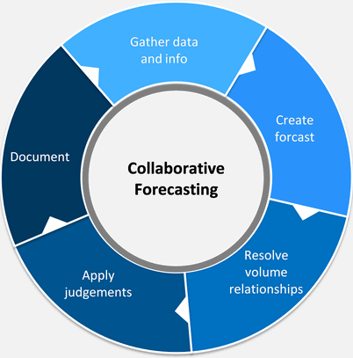
Figure 2: Demand planning cycle
Demand Planning Meetings Process:
Participants | Responsibilities | Deliverables
- Process Leaders (optional)  - Service Line Directors  - IR Leadership  - Process Subject Matter Experts | - Representing respective business lines and process areas  - Providing specific direction regarding tactical work that aligns with strategic objectives  - Mitigating or escalating risks, constraints, and conflicts as appropriate  - Establishing a recommended technology release plan by IT service  - Authorizing/approving recommended technology release plans for TEC/Enterprise  - Ensuring approved release plans have approved funding sources  - Providing process oversight and visibility of technology delivery and performance | - Proposed Enterprise Technology Release Plan  - List of legitimate and prioritized requests that align with enterprise strategies; and  - Appropriate supporting business rationale for requests including business problem, benefit, and proposed funding source

Elements of Demand Planning Process
The processes involved in demand planning are:
- Trade promotion management (TPM)
Trade promotions are marketing tactics (most often in retail companies) that focus on generating in-store demand through discounts, giveaways, in-store promotions, and other similar techniques. Trade promotion management is designed to help brands stand out from their competition through highly coordinated promotion activities and builds stronger connections with retailers.
Top-down and bottom-up trade promotion management and analysis includes profit and loss data, creating insights around promotion spending. It also tracks and identifies which promotions don’t optimize margins due to ineffective trade promotion spending and poor brand growth from trade promotions, and creates maximum ROI using a broad range of data.
- Product portfolio management (PPM)
Product portfolio management is the process of managing every facet of the product lifecycle, from new product introduction to end-of-life planning. The goal of product portfolio management is to maintain a high-level view of the entire portfolio and reveal where product lines are interconnected and interdependent.
Product portfolio management includes planning for fitting new products into the existing product portfolio, understanding how introducing those new products will affect other products (cannibalization), and the analysis of attachment rates (how the sales of one product affects the sales of another).
- Statistical forecasting
Statistical forecasting in demand planning leverages historical data to generate supply chain forecasts using various advanced statistical algorithms. In demand planning, it’s essential to have data-backed forecasts to avoid stock-outs or overstocks and ensure that customers are satisfied.
Demand planners can analyze many algorithms and decide which forecast is most accurate by reviewing each model’s accuracy and bias measures. Then they can choose from the best model for each product and product family.
With statistical forecasting, demand planners can quickly identify outliers and exclusions based on user-defined parameters, including standard deviation or the inter-quartile range.

Demand Planning Tools
There are various manual and automated Demand Planning tools available. Selection of the right tool depends on the scale of business, product range and distribution network. There are mainly three types of Demand Planning tools widely used in the business environment –
- Excel based Demand Planning
- ERP integrated Demand Planning module
- Demand Planning software solution
Management needs to ensure structured Demand Planning training for all Demand Planners and key stakeholders. New features and functionalities also need to be communicated across the organization and key users need to be trained accordingly.

Demand Planning Methods
Selection of appropriate selection of a Demand Planning method is dependent on the type of product, type of demand, manufacturing strategies, distribution model, data collection approach, etc.
The following are the popularly used Demand Planning methods:
- Make-to-stock DP
- Make-to-order DP
- Time Series forecasting
- Demand Sensing
- Demand Shaping
- Bottom-up DP Approach
- Top-down DP approach
- Demand and Capacity Management
From a strategic perspective, demand management is about matching supply to demand. Consumption produces demand and production consumes demand in a highly synchronized pattern. Unlike goods, services cannot be manufactured in advance and stocked in a finished goods inventory in anticipation of demand. Demand and capacity are far more tightly coupled in service systems even when compared with just-in-time (JIT) manufacturing.
It is important to note the difference in scope between Capacity and Demand Management processes. At first, glance the scopes of capacity and demand management seem to overlap, and demand management might be just one aspect of capacity management.
However, this is an oversimplification of both processes. Both are concerned with achieving the same business outcomes, and both are concerned with optimizing investment, but the processes themselves are different. To generalize, demand management focuses primarily on the business and user aspects of providing services, whereas capacity management focuses primarily on the resourcing and technology aspects.
Capacity Management needs to be included in all strategic, planning and design activities, being involved as early as possible within each process, such as:
- Assisting and supporting the development of Service Strategy
- Involvement in the review and improvement of IT strategies and policies
- Involvement in the review and improvement of technology architectures
Each time a user consumes a service demand is presented to the service provider, and this consumes the capacity of the service assets. This, in turn, results in the service being supplied to meet the consumer’s demand.
The greater the consumption of the service, the higher the demand, the higher the consumption of the capacity and the more of the service is supplied. This cycle of demand and supply will only function effectively while the service assets have available capacity.
As soon as the capacity is no longer available, the service provider will not be able to supply enough of the services to satisfy customer demand. For this reason, a major part of demand management is to understand the potential demand and the impact of the demand on the service assets. This allows capacity management to manage service assets (and investments) towards optimal performance and cost. The productive capacity of resources available to a service is adjusted according to demand forecasts and patterns.
Some types of capacity can be quickly increased as required and released when not in use. The arrival of demand can be influenced using pricing incentives. However, it is not possible to produce, and stock service output before demand materializes.
- Demand types and classification
IT demand may come from many different sources and formats, demands can be divided into three main categories. These categories and examples are described in figure below:
Demand Types | High-level Management Process | Sub-level Management Process | Examples
Strategic | Project Portfolio Management (PPM) | - Clearly identify strategic objectives  - Take a full lifecycle approach to investments and benefits realization  - Use a fact-based process for decision making | - Embed relationship managers  - Use a standards business case template with financial return  - Use a product plan to address upgrades and retirement / replacement
Tactical | Service Portfolio Management (SPM) | - The service catalogue is the heart of SPM  - Automated workflows for ordering, approving, and delivering  - Information for IT and user management | - Catalogue a service  - Process a request
Operational | Asset Management  Application Portfolio Management | - Keep desktops and infrastructure software up to date  - Comply with regulations  - Support the applications  - Maintain the hardware | Install and configure exchange server  Deploy latest Microsoft patch  Take inventory of application software

Section B: Process Flow
- Demand Management Process Flow
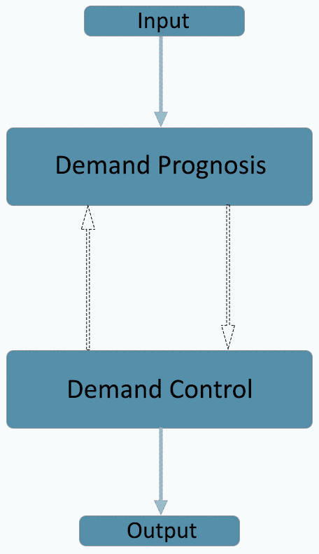
Figure 3: Demand Management process
The Demand Management process flow consists of the following tasks.
- Submitting ideas
- Creating demands
- Adding details to demands
- Assessing demands
- Completing demands

Demand Management has two sub-processes. All the sub-processes and their objectives are described below.

Demand Prognosis
In demand prognosis, the business relationship manager analyses IT service consumption. This individual will also forecast future consumption based on known information, such as consumption trends and service-quality feedback from the customer. Sometimes, the customer will directly indicate when more capacity or a great number of services are needed, it is called as Pattern of Business Activity (PBA).

Demand Control
Demand control is the way that providers control IT service consumption. This can be done through technical means (such as network throttling) or financial means (such as increased charges for usage higher than the agreed-upon levels). The control is implemented until the capacity for greater demand is implemented into the service catalo.
Developing differentiated offerings and service packages also controls demand. Differentiated offerings and service packages control demand and cost while providing the customer with the services they use and value most.

Process Activities of Demand Management
The following process activities and methods can be applied when required to perform demand management:
- Pattern of Business Activity (PBA)
- User Profiles (UP)
- Activity-based Demand Management
- Develop Differentiated Offerings
- Management of Operational Demand

Pattern of Business Activity (PBA)
The pattern of business activity represents the dynamics of the business and includes interactions with customers, suppliers, partners, and other stakeholders.
Sometimes, the customer will directly indicate when more capacity or a great number of services are needed. In ITIL, this is called the Pattern of Business Activity (PBA). According to ITIL, the PBA is a workload profile of one or more business activities that helps service providers establish usage patterns.
The pattern of business activity measures the following aspects of customer service usage:
- Frequency: The frequency of usage is how often the volume of usage occurs.
- Volume: The volume of usage is the amount of activity. For example, this could be the number of transactions processed or a service desk ticket number. Volume can increase or decrease.
- Duration: The duration of usage is how long the pattern of business usage lasts. Does peak database usage occur only during business hours, for example, or only during certain months? How long ago did the increase or decrease in usage begin?
- Location: The location of usage is where the business usage occurred. Is it in the service desk or the sales department, for example?
Some of the benefits of analysing PBA are in the form of inputs to service management functions and processes such as the following:
- Service design can optimize designs to suit demand patterns.
- Capacity management translates the PBA into workload profiles so that the appropriate resources can be made available to support the levels of service utilization.
- Service catalogue can map demand patterns to appropriate services.
- Service portfolio management can approve investments in additional capacity, new services, or changes to services.
- Service operation can adjust the allocation of resources and scheduling.
- Service operation can identify opportunities to consolidate demand by grouping closely matching demand patterns.
- Financial management for IT services can approve suitable incentives to influence demand.
Codifying of PBAs
Codifying patterns helps multidimensional Analysis. Uses criteria such as likeness and nearness. Develops a simple and standard catalogue of patterns. Reduces the number of patterns, make analysis easier, and avoid complicated solutions.

User Profiles (UP)
The PBA also includes a user profile, which is a pattern of service usage that is tied to a type of user. For example, developers may have a higher database usage pattern than business users.
Each User Profile can be associated with one or more patterns of business activity based on roles and responsibilities within the organization. User profiles are constructed using one or more predefined patterns of business activity.
Like Patterns of Business Activity (PBA), User profiles should be identified and analysed for their relationship to the patterns of demand generated in the business. User profiles are defined in the context of the roles and responsibilities within the organization for people, functions, processes, and applications. In some cases, a user profile will be defined for an automated process, which will have its own demand for supporting services.
When demand is defined using pattern of business activity and user profiles, service providers can serve demand with services, service levels and assets which are matched appropriately.
When defining user profiles, they will be associated with one or more PBA, which requires both customers and the service provider to have a clear understanding of the business activities and how various roles are related.
The following table is an example of User profiles defined by Demand Management:
User Profile | Applicable Pattern of Business Activity | PBA Code
Senior Executive (UP1) | Moderate domestic and international travel, highly sensitive information to be protected, high urgency for service requests, communication services need to be highly available. | 33B  17D  21A
Office-based Managers | Low domestic and international travel, medium sensitive information, medium urgency for service requests, communication services need to be highly available | 33D  17B  21A
Office-based Staff | No domestic and international travel, low sensitivity information, low urgency for service requests, communication services require medium availability | 33A  17E  21C

In the above table, the PBA code would be referencing previously defined patterns of business activity, which helps clarify when will each type of user will typically generate demand for IT services and what level of demand will there be. This is valuable information which can be used for then predicting the potential impact that adding or removing staff members (users) may have on the demand for IT services and the ability of the IT service provider to meet those demands.

Activity-based Demand Management
By analysing and tracking the activity patterns of business, the demand for IT services which support the process can be predicted.
Activity-based demand management can consolidate demand patterns and ensure that the customer’s business plans are in sync with the capacity management plans. Analysing and tracking the activity patterns of the business process makes it possible to predict demand patterns for services in the catalogue that support the process.
It is also possible to predict demand for underlying service assets that support those services. Every additional unit of demand generated by business activity is allocated to a unit of service capacity. Demand patterns occur at multiple levels. Activity-based demand management can daisy-chain demand patterns to ensure that the business plans of customers are synchronized with the service management plans of the service provider.
Over time, Demand Management should be able to build a profile of business processes and the patterns of business activity in such a way that seasonal variations as well as specific events (e.g. adding new employees) can be anticipated in terms of associated demand. Using this information will help various elements of the Service Lifecycle, including the following:
- Service Design: Particularly Capacity and Availability Management, who can optimize designs to suit demand patterns.
- Service Transition: Change Management and Service Validation and Testing can ensure that appropriate levels of warranty can be provided.
- Service Operation: Can optimize the availability of staff based on patterns of demand; and
- Continual Service Improvement: Can identify opportunities to consolidate demand or introduce improved incentives or techniques to be utilized in influencing demand.
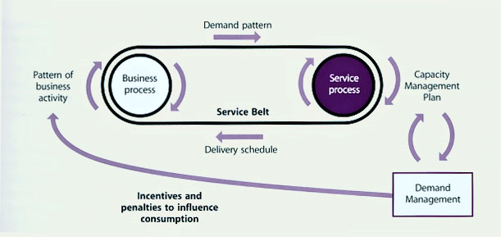
Figure 4: Capacity management takes note of Demand management
Critical to the effective application of Demand Management is a forward-looking Capacity Plan, which should identify how capacity will be produced to meet the predicted demand patterns, including the level of excess capacity deemed appropriate in accordance with the business requirements for service value.

Develop Differentiated Offerings
Analysing the pattern of business activities may help to identify that varying levels of performance are required at different times.
In such cases, it is important to work along with service portfolio management to define the service packages which meet the variations in the patterns of business activity.
Demand Management needs to work closely with the other Service Strategy processes (Financial Management & Service Portfolio Management), as well as Service Level Management in ensuring the appropriate development of Service Packages that suit identified patterns and types of demand.
In a basic approach, this may be as simple as Gold, Silver and Bronze offerings to influence the adoption and use of IT services.

Management of Operational Demand
This involves managing or influencing the demand where services and resources are being utilized over the limit.
The most obvious and clear model to describe demand management as a progressive process is as a funnel or pipeline in which on the top is demand capturing stage. Meaning all the ideas, opportunities or requests identified and gathered by business. In this phase only the high-level schedule and financial framework is needed in addition to benefits in the overall level. In the next phase is for to build business case. In this phase, a closer look to the demand item is taken. The aim is to create as accurate and realistic business case as possible. With cost estimation and/or cost-benefit estimate for approval decision making.
Pipeline approach is demonstrated in figure below:
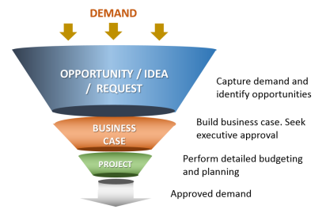
Figure 5: Demand pipeline approach

Section C: Roles and Responsibilities
- User Roles and Functions
The responsibilities of various user roles in Demand Management are listed as follows:
Roles | Responsibilities
Demand Manager | - The Demand Manager is responsible for understanding, anticipating, and influencing customer demand for services.  - The Demand Manager works with capacity management to ensure that the service provider has enough capacity to meet the required demand.  - Responsible for overall Demand Management process  - Manage the overall demand from different sources  - Work with Capacity Manager to provide information about demand  - Create required demand report for short- and long-term demand  - Work closely with FEA (overall), SA, platform engineering, DRIs and TAO to understand business needs and review roadmap  - Identify areas of improvement and work with required resources to implement them  - Understand & set size criteria/requirements for roadmap, design, and capacity
Demand Analyst (Design) | - Support demand manager activities  - Key contact for specific DRI or TAO and FEA, SA  - Collect demand information  - Collect data and provide reports to demand manager
Capacity Manager (Ops) | - Responsible for overall capacity management process  - Work closely demand manager to understand business demand  - Translate business needs (demand) to infrastructure capacity requirements  - Support the creation of the capacity plan  - Approve unplanned capacity requests  - Responsible for operational activities (reactive D2D and proactive, planning, what if analysis)  - Oversee all provisioning and queue management activities  - Provide input to standards for the request acceptance criteria  - Enforce capacity management policies related to all requests and stop provisioning for requests the violate the policy and return them to demand management
Capacity Operations (Ops) | - Monitor current capacity  - Manage current capacity  - Run daily and weekly health reports  - Set guidelines for rightsizing and balancing the environment  - Validate and approve capacity requests  - Manage idle/powered VMs  - Support Incident and Problem Management  - Manage the available assets in DB inventory
Leadership | - Provide guidance and feedback to the team  - Review dashboards and understand the capacity situation  - Make strategic decision related to capacity expansions

- RACI Matrix
The following RACI chart outlines which positions are Responsible, Accountable, Consulted, and Informed for each service desk process.
Sr. No. | Activity Description | Demand Manager | Demand Analyst | Capacity Manager | Capacity Operations | Leadership
Demand Management Governance
1 | Document & improve demand management process | AR |  | C | C | I
2 | Establish and communicate the demand policy | AR |  | C | C | R
3 | Drive adoption of the processes, procedures & policy | R |  | C | C | A
4 | Communicate policies & expectations with business | C |  | C | C | RA
5 | Implement & configure demand management system (i.e., ITBM) | R |  | C | C | A
6 | Identify & implement process improvements | AR |  | C | C | R
Demand Planning, Data Collection, Validation & Reporting
7 | Provide 6+ months of workload migration capacity requirements | C |  | IC |  | I
8 | View the request report for trending information | R | R | R | R | A
9 | Provide long term requirements for capacity | A | C | C | C
10 | Validate demand date | RA | R | C |  | C
11 | Review impact on roadmap and design | R | R | R | R | A
12 | Develop short- & long-term demand reports | RA | R |  |  | C
13 | Develop trending reports | RA | R |  |  | C
14 | Provide reports to capacity management | RA | R | I | I | I
15 | Update and improve demand data and reports | RA | R | C | C | C
16 | Review SDDC roadmap | RC | RC | RC | C | A

Section D: Governance and Process Controls

- CSF and KPI
Like the rest of Service Offerings & Agreements, the measurement of success should be assessed using balanced perspective that considers the relationships and sometimes conflicting demands between the different processes involved. Some of the specific Critical Success Factors (CSFs) and their respective Key Performance Indicators (KPIs) for Demand Management include:
Sl. No. | CSF | KPI
1. | The service provider has identified and analyzed the patterns of business activity and is able to use these to understand the levels of demand that will be placed on service. | - Patterns of business activity are defined for each relevant service.  - Patterns of business activity have been translated into workload information by capacity management.
2. | The service provider has defined and analyzed user profiles and is able to use these to understand the typical profiles of demand for services from different types of users. | - KPI Documented user profiles exist, and each contains a demand profile for the services used by that type of user.  - KPI Patterns of business activity are defined for each relevant service. KPI Patterns of business activity have been translated into workload information by capacity management.
3. | The service provider has defined and analyzed user profiles and is able to use these to understand the typical profiles of demand for services from different types of users. | - Documented user profiles exist, and each contains a demand profile for the services used by that type of user.
4. | A process exists whereby services are designed to meet the patterns of business activity and meet business outcomes | - KPI Demand management activities are routinely included as part of defining the service portfolio.
5. | There is a means to manage situations where demand for a service exceeds the capacity to deliver it. | - Techniques to manage demand have been documented in capacity plans and, where appropriate, in service level agreements.  - Differential charging (as an example of one such technique) has resulted in a more even demand for the service over time.
- Inter-relationships with other ITIL processes
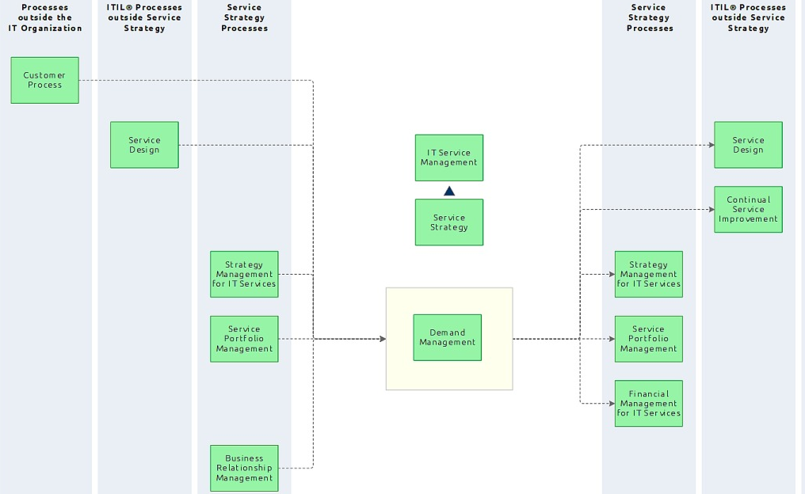
Figure 6: Demand management inter-relationship with other processes

Service Portfolio Management
Demand management is seen in service strategy when the pattern of business activity is used alongside service portfolio management to invest in new services and increased capacity.
As a part of service strategy stage, it is closely aligned with service portfolio management, financial management for IT services and business relationship management. This is because the question of “how much” service is enough is integral to those processes. In financial management, for example, the question of how much of a service to provide directly impacts the IT budget and the costs passed on to the service customer. In service portfolio management, demand directly impacts which services are offered in the customer service catalog. service operations are thus also impacted, since it relies on the service catalog for its range of services, as well as on the associated capacity and asset management of operations.

Service Catalogue Management
Demand Management is seen in service transition when the data collected is used to validate that the new service catalog meets the projected needs of the pattern of business activity.

Service Desk
Demand Management is used in service operation as the end point for feedback from the service desk. The service desk detects trends in service usage and sends that information to demand management, which alerts capacity management to increase or decrease resources as needed.

Continual Service Improvement
Finally, demand management is seen in continual service improvement (CSI) when the data from demand management and the PBA is used to proactively improve services based on usage forecasts.

Section E: Appendix
- References
Guidance | Section
ISO 20000-1:2018 | Clause 8.4 – Supply and Demand (Demand Management)
ITIL 4 | ITIL Specialist – Drive Stakeholder value

