




Configuration Management Process
Standard Practice Document


GAVS Technologies N.A., Inc
116 Village Blvd, Suite 200, Princeton,
New Jersey 08540, USA.
http://www.gavstech.com
Document Version
Document Revision Number | 2.3
Effective Date | 13-Jan-23
Owner | GAVS Quality Team
Modified by | Gouri Mahendru
Approved by
Document Revision History
Version No. | Release date | Summary of changes | Prepared by | Approved by
1.0 | 1-Oct-19 | Initial Document | Rama Vani Periasamy | Sekar T
2.0 | 30-Jan-20 | Added CMDB Template | Rama Vani Periasamy | Sekar T
2.2 | 1-Jun-20 | Updated as per ISO 20000-1:2018 reference | Santhiya P | Sekar T
2.3 | 13-Jan-23 | Updated sections A-5, A-6, A-7, D-4, E-1, E-2 | Gouri Mahendru

Table of Contents
Section A: Introduction 5
1. Overview 5
2. Definition 5
3. Purpose 5
4. Scope 5
5. How ITAM and Service Configuration Management works together? 5
5.1. Build a Configuration Management Database (CMDB) 6
6. CI Types 8
7. Configuration Management System (CMS) 8
8. Benefits of Configuration Management 9
Section B: Process 10
1. Configuration Management High-level Process 10
1.1. Configuration Management and Planning Process 11
1.2. Configuration Identification Process 12
1.3. Configuration Control Process 12
1.4. Configuration Status Accounting Process 15
1.5. Configuration Verification and Audit Process 16
Section C: Roles & Responsibilities 17
1. Roles, Competencies & Responsibilities 17
2. RACI Matrix 19
﻿Section D: Governance & Process Controls 20
1. Process Controls 20
2. Key Metrics 20
3. Reports 20
4. Inter-relationships with other Processes 21
﻿Section E: Appendix 22
1. References 22
2. Templates 22
2.1. CMDB Template 22
2.2. Configuration Audit Verification Template 22
2.3. Configuration Plan (CM Plan) Template 22

Table of Figures
Figure 1: Example of a Logical Data model of CMDB 6
Figure 2: CI Types 8
Figure 3: Configuration Management Lifecycle Process 10
Figure 4: Configuration Planning Process 11
Figure 5: Configuration Identification Process 12
Figure 6: CI Addition Process 13
Figure 7: CI Addition Process 13
Figure 8: CI Decommission Process 14
Figure 9: Configuration Status Accounting Process 15
Figure 10: Configuration Verification and Audit Process 16

Section A: Introduction

Overview
The following Configuration Management Process has been designed for the GAVS IT Service Management program. It will be used as a reference for the implementation and use of the Configuration Management process on an ongoing basis. This process document is based on the best practices described in the Information Technology Infrastructure Library (ITIL®) 4.

Definition
Configuration Items (CI) is defined as any component that needs to be managed in order to deliver an IT service. It is a subset of service asset that has a direct impact on service delivery and needs to be managed to deliver an IT service. An organization’s Configurations could be its include locations and offices, employees and customers, software and applications, documentation, hardware, incidents, modifications, and clients.

Purpose
The purpose of this standard operating procedure (SOP) is to ensure that accurate and reliable information about the configuration of services, and the configuration items that support them, is available when and where it is needed. This includes information on how configuration items are configured and the relationships between them. This document will serve as a best-practice guide and can be used to train new staff who will be involved in Configuration management. This SOP is a step-by-step guide to plan and manage the full lifecycle of all Configurations to help the organization.

Scope
The scope of the Configuration Management process refers to the extent or boundaries to which the Configuration Management process is applied.
- Classifying the Configuration portfolio according to type, model, manufacturer, and so on, from introduction to disposal whether in the productive or non-productive state
- Managing the lifecycle of Configurations
- Associating Configurations to people, places, things, cost center, cost type, purchase order and contract
- Tracking costs related to Configurations.
- Tracking contracts related to Configurations.
- Reconciling data on the Configuration identifier
- Recording Configuration attributes useful for the Service Management processes
The goals for the Configuration Management process are to:
- Support many of the ITIL processes by providing accurate configuration information to assist decision making.
- Minimize the number of quality and compliance issues caused by incorrect or inaccurate configuration of services and assets
- To define and control the components of services and infrastructure and maintain accurate configuration information on the historical, planned and current state of the services and infrastructure

How ITAM and Service Configuration Management works together?
Service Configuration Management often starts with a good IT asset register and pulls information into a Configuration Management Database or CMDB of some sort, a main place for information about Configuration Items or CIs.
Configuration Items are a bit different than regular IT assets in a few key ways:
- CIs may or may not be tangible (CIs can include key documentation like SLAs or knowledge articles, virtual servers or networks, as well as locations, services, and/or people), whereas assets tend to be tangible.
- CIs may or may not have financial value tied to them; whereas assets do.
- CIs have relationships with other CIs in support of an overarching product or service, whereas assets may or may not.
There can be a lot of overlap between CIs and assets. However, not every CI is an asset; and not every asset is necessarily going to be a CI. It is helpful to talk with your teams about what should be treated as an asset and what will be considered a CI.

Build a Configuration Management Database (CMDB)
Once you’ve figured out your CIs, you’ll want to begin building your CMDB - A database used to store configuration records throughout their lifecycle. It also maintains the relationships between configuration records that are under the control of Change Management.
It means that any service asset (be it hardware, software, contract, SLA) that should only be modified under an approved request for change (RFC).
Note: Most organizations do not track things like free software, keyboards, and mice, sometimes even monitors. This is primarily because 1) these items are generally very low cost, and 2) they are very hard to track. However, if you do happen to track these types of service assets, that’s OK, too. Just remember that they must also be maintained under Change Management.
To build a logical CMDB, follow the below mentioned 7 steps:

Build a Logical Data Model of the Service Asset & Configuration Management Process with Relationships
The logical model defines the scope of SACM activities or it explains how deeply the organization would like to trace SACM relationships.
For example, at a basic level, it is possible to draw relationships between key services and the underlying infrastructure (hardware, servers, software, and interfaces). At the other extreme, SACM could trace relationships down to the workstation level. ITIL recommends starting with a high-level approach by defining several key services and tracing them back to servers and interfaces.
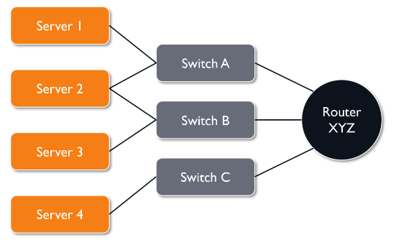
Figure 1: Example of a Logical Data model of CMDB
If you have a logical model like the one in the example above, you know Server 2 is connected to redundant Switches A and B, which are in turn uplinked to Router XYZ, and that Server 2 is critical to the business as it relates to Service for GAVS, then you have the type of risk analysis data that will help determine the likelihood that you can reboot Router XYZ at 2:00PM on a Thursday afternoon without causing an unplanned, major outage. Therefore, maintaining the CMDB is so critical. Without vigilant updates, it becomes an obsolete data repository that no one trusts, and it undermines your organization’s Change Management process.

Define CI types.
Essentially, this entails categorizing any and all configuration items based on the logical model defined in above step which you’re interested in managing (server, switch, router, database, etc.).
Trying to map all the relationships and keep track of every asset you have is going to be extremely difficult, so start small. Focus on:
- What are the most important things you need to keep track of?
- Where are your weak points?
- What is currently in scope for Change Management?

Assign an owner to each CI type.
Identify and assign an owner for each CI type identified in Step-2. The CI Owner will be responsible for the remaining steps for their respective CIs. For example, if Jane is the owner of all your servers, she will be responsible for deciding what information we need to know about each server, and how to gather that information.

Define attributes for each CI type.
The CI owners will define attributes for their respective types. An Attribute, as per ITIL, is a piece of information about a CI such as name, location, version number, or cost. In our example above, Jane will define all the attributes we need know about our servers and record them in the CMDB.

Identify sources of information for CIs (i.e., Discovery)
Once CIs, attributes, and owners have been defined, it’s important to understand where that information can be found. For example, an auto discovery tool could be used to identify related components on the network. Other options include visually inspecting hardware components to obtain serial numbers, reviewing purchase and warranty documentation, and even reviewing invoices.

Map relationship between Assets
This step provides context to the information collected in previous steps. Here, we are mapping relationships between components. This is akin to taking the logical data model created in Step One and overlaying it with the actual hardware, software and infrastructure components that exist in your environment. When feasible, an auto discovery tool can dramatically reduce the amount of time it takes to perform this mapping. If using auto discovery is not possible, relationships can be drawn manually.
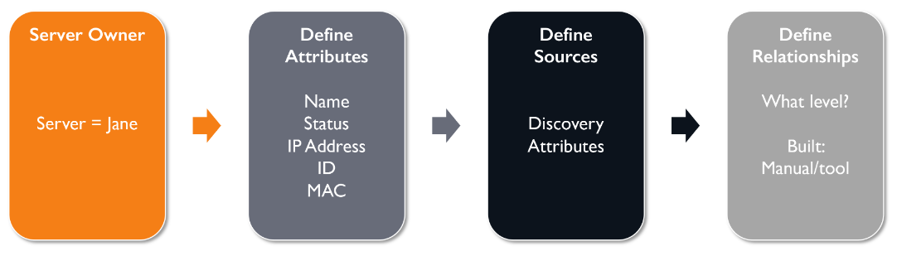

Rollout one CI type at a time – Don’t try to do all at once!
In this step, CI types and associated attributes are built or loaded in the CMDB. An incremental approach works best here. Build out one CI type first and verify that it is correct before moving on to the next. For example, if you start with Servers, identify all of the servers, then identify all the attributes and owners associated with each one. Your last step – an extremely important one – before moving on to the next CI type is to verify that the relationship mapping between servers and other components is correct. When that is confirmed, onward.

CI Types
CIs are categorized into six as shown in the following diagram:
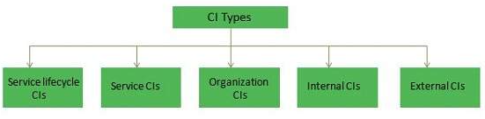
Figure 2: CI Types

Service Lifecycle CIs
Service lifecycle CIs gives clear picture on:
- Services
- How services will be delivered?
- What benefits are expected?
- Service cost

Service CIs
Service CIs refers to −
- Service model
- Service package
- Release package
- Service resource assets
- Service capability assets

Organization CIs
Organization CIs are internal to an organization but independent of the service provider.

Internal CIs
CIs which are delivered by individual projects are known as Internal CIs.

External CIs
External CIs refer to external customer requirements and agreements, releases from supplier and external services.

Interface CIs
These CIs are required to deliver end-to-end service across a Service Provider Interface (SPI).

Configuration Management System (CMS)
Configuration Management System (CMS) contains one or more Configuration Management Databases (CMDB). The database contains information associated with a CI such as supplier, cost, purchase date, renewal date for licenses and maintenance contracts and other related documents such as SLA etc.
There are also other attributes for Configuration Items such as −
- Unique Identifier
- CI type
- Name/description
- Supply date
- Location
- Status
- License details
- Related document masters
- Related software masters
- Historical data
- Relationship type
- Application SLA
- Service Assets and Configuration Process

Benefits of Configuration Management
- Accommodates changes to and reuse of standards and best practices.
- Significantly reduces incident resolution time by using a central repository for critical infrastructure data that can be accessed by other applications.
- Includes configuration grouping and business relationships.
- Enables you to meet business and customer control objectives and requirements.
- Provides accurate configuration information to enable people to make decisions at the right time. For example, to authorize changes and releases or to resolve incidents and problems faster.
- Minimizes the number of quality and compliance issues caused by improper configuration of services and assets.
- Optimizes the use of service assets, IT configurations, capabilities, and resources.

Section B: Process

Configuration Management High-level Process
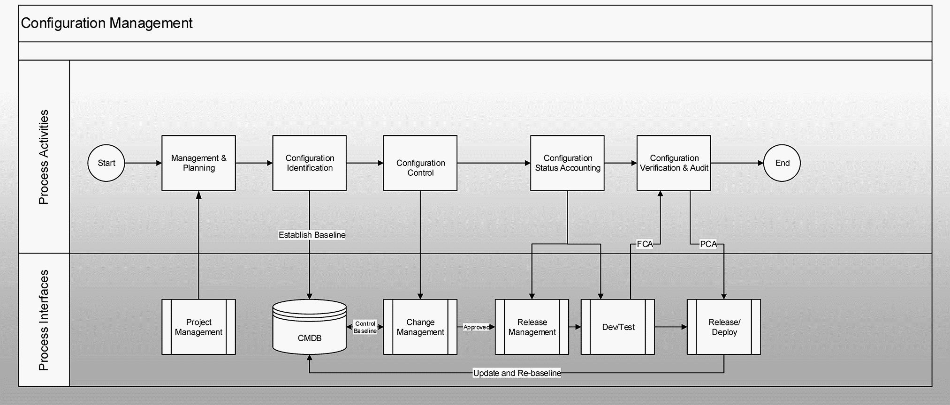
Figure 3: Configuration Management Lifecycle Process
The Configurations typically goes through different lifecycle stages, like:
- Management and Planning
- Identification
- Configuration Control
- Status Accounting & Reporting
- Verification and Audit

Configuration Management and Planning Process
Objective: This activity plans and defines Configuration Management's purpose, scope, objectives, policies and procedures with the relevant organizational and technical considerations.
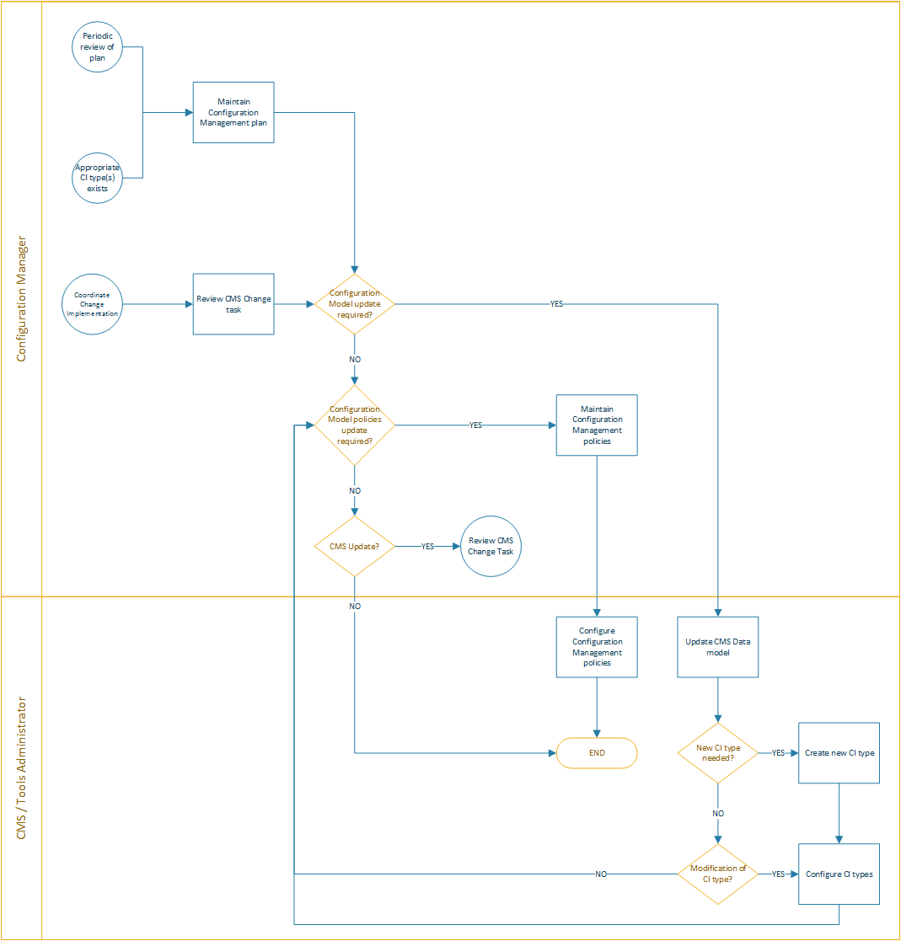
Figure 4: Configuration Planning Process
It is important to get the right level of detail (too detailed makes it complex and expensive to administer, too little provides little value). It is important to devote sufficient time to this stage as corrections further down the road will be more costly to 'retro-fit'. Defining a data model is key, this will enable the organization to determine to which level of CI needs to recorded and subsequently managed. If the level is too low, control will be time consuming and adding little value.
This is also the time to evaluate the tools needed to support the function so this is where the CMDB and associated tools should be chosen (once the requirements are understood). Other tools that are associated include those that 'discover' infrastructure components on the organization’s network(s). These are vital in maintaining information about CIs as otherwise a manual approach would be needed and this can be error-prone and expensive. Unfortunately these tools cannot be used automatically for non-networked equipment and so different procedures will need to be considered for this.
As IT becomes more pervasive all sorts of 'non-standard' devices may be considered as part of the IT infrastructure (including PDAs, smart watches, wireless network access points, medical scanners and industrial robots).

Configuration Identification Process
Objective: To define and maintain the underlying structure of the CMS (the Configuration Model), so that it can hold all information on Configuration Items (CIs). This includes specifying the attributes describing CI types and their sub-components, as well as determining their interrelationships.
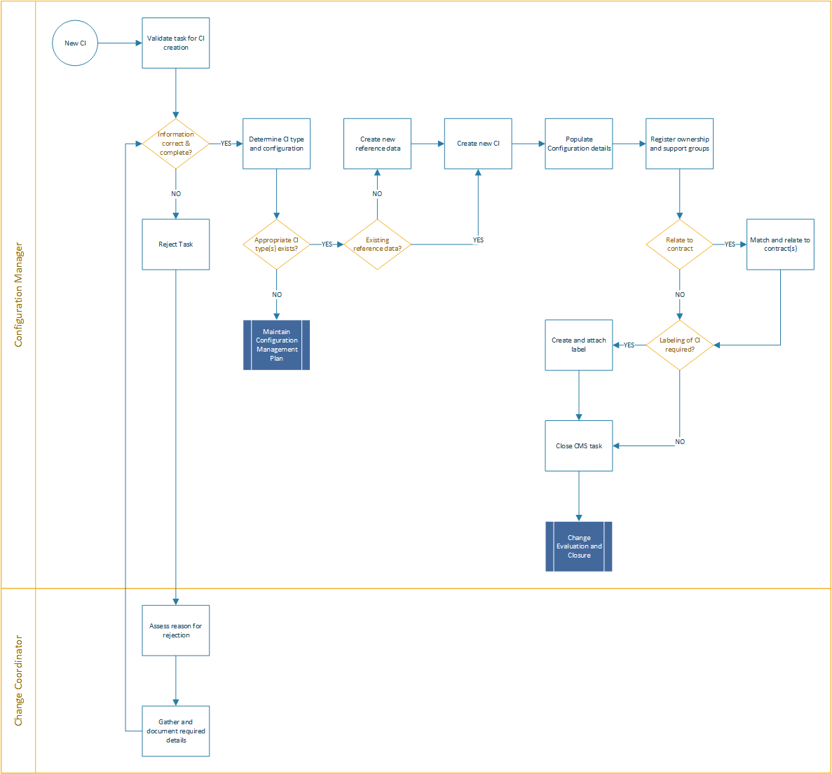
Figure 5: Configuration Identification Process
This activity selects and identifies the configuration structures for all infrastructure CIs, including their owners, their interrelationships and configuration documentation. It should also include setting up an identification scheme for all items, allocating identifiers and version numbers to CIs, labelling each physical item and recording details in the CMDB.

Configuration Control Process
Objective: To ensure that no Configuration Items are added or modified without the required authorization, and that such modifications are adequately recorded in the CMS.
This activity ensures that only authorised and identifiable CIs are accepted and recorded in the CMDB and that these are managed for their entire lifecycle from receipt to disposal. It ensures that no CI is added, modified, replaced or removed without appropriate controlling documentation (an approved Change Request and updated specification, where appropriate).

3a. CI Addition Process
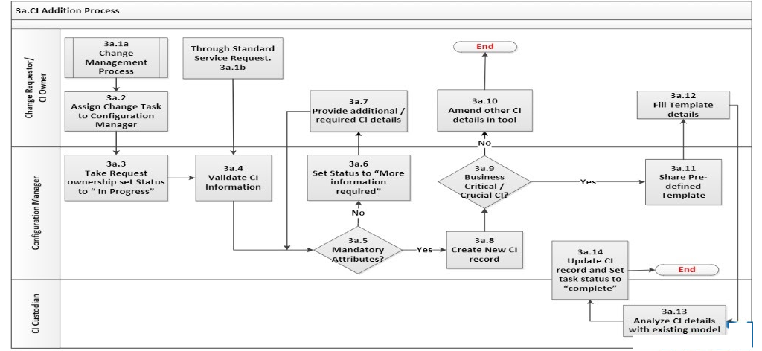
Figure 6: CI Addition Process

3b. CI Update Process
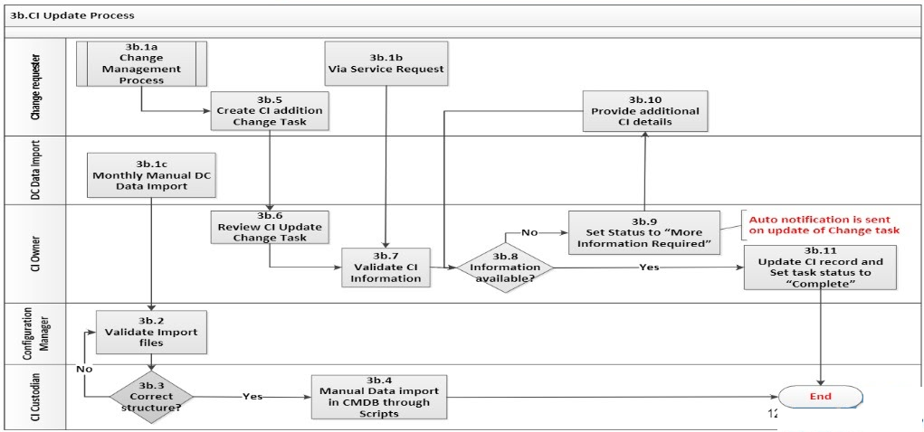
Figure 7: CI Addition Process

3c. CI Decommission Process
Figure 8: CI Decommission Process

Configuration Status Accounting Process
Objective: This activity provides reporting capabilities for all current and historical data for each CI throughout its lifecycle. This enables changes to CIs and their records to be tracked from 'ordered' through to 'end-of-life'.
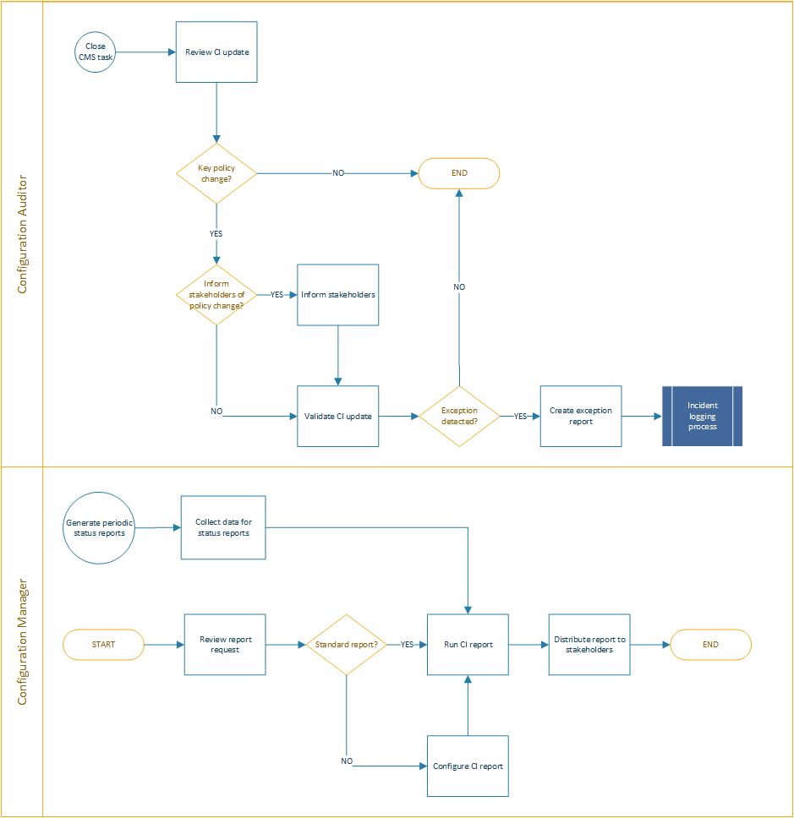
Figure 9: Configuration Status Accounting Process

Configuration Verification and Audit Process
Objective: To ensure that no Configuration Items are added or modified without the required authorization, and that such modifications are adequately recorded in the CMS.
This activity ensures that reviews and audits to verify the physical existence of CIs are conducted at appropriate intervals. It also ensures that details of these are checked in the CMDB, and that corrective measure are triggered should there be missing, out-of-date or erroneous information held therein. An initial audit should be done soon after the first introduction of ITIL Configuration Management. Thereafter audits should be conducted at random and at a frequency based on results (many exceptions, more frequent).
The Configuration Manager will need to assess efficiency and effectiveness of Configuration Management on a regular basis. This should include checks to ensure that all changes to the IT Infrastructure have been properly authorised and details recorded correctly and in a timely manner in the CMDB.
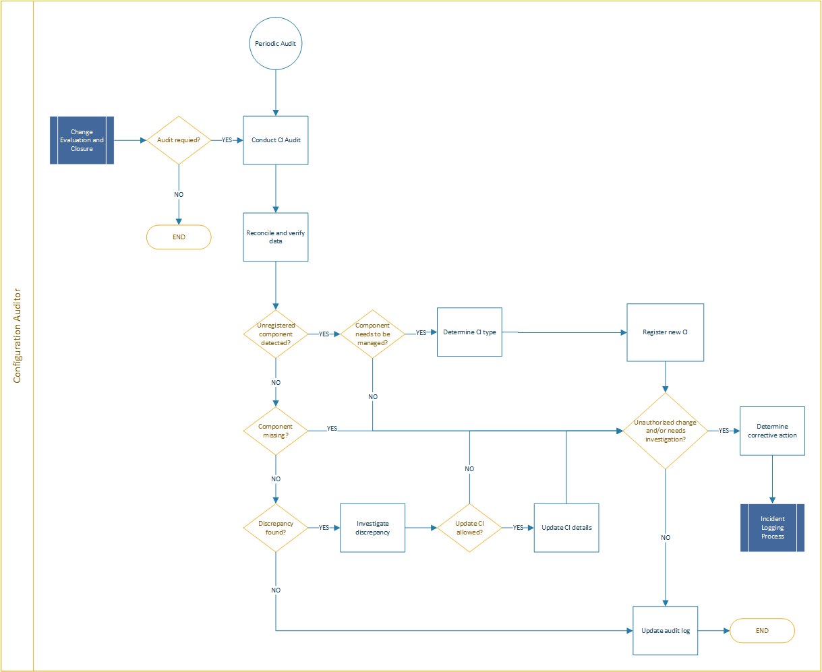
Figure 10: Configuration Verification and Audit Process

Section C: Roles & Responsibilities

Roles, Competencies & Responsibilities
Roles are described in the context of processes and activities. Roles are not job titles; one person can take on multiple roles and one role can be assigned to multiple people.
Roles | Responsibilities
Configuration Process Owner | - Owns the Configuration Management Process at all levels
Configuration Manager | - Managed the operational activities.  - Implements the service asset and configuration management policy and standards.  - Evaluates existing asset and configuration management systems and the design, implementation, and management of new/improved systems for efficiency and effectiveness  - Agrees scope of the asset & configuration management processes, function, the items that are to be controlled, and the information that is to be recorded  - Develops asset and configuration management standards, plans and procedures  - Ensures that the asset and configuration management methods and processes are properly approved and communicated to staff before being implemented  - Arranges recruitment and training of staff.  - Agrees assets to be uniquely identified with naming conventions; ensures that staff comply with identification standards for object types, environments, processes, lifecycles, documentation, versions, formats, baselines, releases, and templates  - Proposes/agrees interfaces with change management, problem management, network management, release management, computer operations, logistics, finance and administration functions  - Plans population of the asset DB; manages the asset DB, central libraries and tools; ensures regular housekeeping of the asset DB  - Agrees CIs to be uniquely identified with naming conventions.  - Ensures that staff comply with identification standards.  - Plans population of the CMS; manages CMS, central libraries, tools, common codes, and data; ensures regular housekeeping of the CMS  - Provides reports, including management
Configuration Analyst / Administrator | - Responsible for ensuring active and consistent update of CMDB.  - Proposes and agrees with the Asset and Configuration Manager CIs to be uniquely identified with naming conventions; ensures that developers and configuration system users comply with identification standards for object types, environments, processes, lifecycles, documentation, versions, formats, baselines, releases and templates  - Liaises with the configuration Administrator/Librarian on population of the CMS  - Manages asset and CMS, central libraries, common codes, and data; ensures regular housekeeping of the asset and CMS  - Uses the CMS to facilitate impact assessment for RFCs and to ensure that implemented changes are as authorized  - Performs configuration audits to check that the physical IT inventory is consistent with the asset and CMS and initiates any necessary corrective action  - Creates and populates project libraries and CM system.  - Maintains project status information and status accounting records and reports
CMS / Tools Administrator | - Evaluates asset and configuration management tools and recommends those that best meet the organization’s budget, resource, timescale, and technical requirements; directly or indirectly customizes proprietary tools to produce effective asset and configuration management environments in terms of  databases and software libraries, workflows, and report generation  - Monitors the performance and capacity of existing asset and configuration management systems and recommends improvement opportunities and undertakes standard housekeeping and fine tuning under change control.  - Provides technical administration and support for the CMS, central libraries, tools’ common codes and data; undertakes regular technical housekeeping of the asset and CMS  - Ensures the integrity and operational performance of the CM systems
Configuration Control Board (CCB) | - Defines and controls the service configuration baselines in terms of core and support services, applications, information, service, technical, infrastructure ensuring that they meet the requirements established in the service design.  - Reviews changes in the service configuration for compliance with standards, contractual and internal requirements
- CI Owner | The CI Owners function involves planning, design, development and implementation activities and they are responsible for:  - Perform impact assessment on RFC and identify any change dependencies.  - Ensure accuracy of CMDB data for owned CIs including relationships to other CIs.  - Creating RFCs for changes they initiate and secure approval for the change.  - Managing the implementation of RFCs for CIs that they own.  - Compiling & maintaining detailed documentation of the configuration of their system

RACI Matrix
Activity Description | CI Owner | Configuration Analyst | Configuration Manager | Process Owner
Process planning and design
Produce configuration management plan |  | C | R | R/A
Define CMDB structure |  | C | R | R/A
Determine CI selection guidelines |  | C | R | R/A
Populate CMDB |  | C | R/A
Perform initial audit |  | R | R/A | C
Baseline CMDB |  | I | R/A | I
Configuration identification
Validate update request | C | R | R/A
Validate CI attributes |  | R | R/A
Review invalid attributes | C | R | R/A
Update CMDB | C | R | R/A
Publish new CI types | I | R | R/A | I
Configuration control
Validate update request | C |  | R/A
Add CI | C | R | R/A | I
Update CI | R | R | R/A
Decommission CI | R | R | R/A
Status Accounting and Reporting
Authorize or reject report request | I | R | R/A
Create or update configuration management report |  | R | R/A
Generate configuration management report |  | R | R/A
Distribute configuration management report | I | R | R/A
Verification and audit
Approve verification and audit request |  |  | R | A
Execute audit |  | R/A
Reconcile with CMDB |  | R/A
Determine corrective action | R/A | I
Initiate corrective CMDB action |  | R/A
Execute corrective action | I | R/A

﻿Section D: Governance & Process Controls

Process Controls
Process controls represent the policies and guidelines on how the process will operate along with the metrics for measuring the process and they provide direction over the operation of process by defining constraints or boundaries within which the process must operate.
Sl.No. | Name | Description
1 | Configuration Management Plan | The plan defines the specific Configuration Management activities. Configuration Management should decide what level of Configuration Management is required for the selected service or project that is delivering changes and how this level will be achieved
2 | Configuration Control | No CI should be added, modified, replaced, or removed without appropriate controlling documentation or procedure being followed
3 | Verification & Audit | Establish a policy to Check that release and configuration documentation is present before making a release.  Plans should be made for regular configuration audits to check that the CMDB and related configuration information is consistent with the physical state of all CIs, and vice versa

Key Metrics
The following are the list of key performance indicators (KPIs) that have been selected for tracking the success of the Configuration Management process. The KPIs will be measured and calculated as a percentage and reflected in the monthly SLA reports.

  - Verification Frequency
  - Number of Incidents owing to inaccurate CMS Information
  - Effort for CMS Verifications
  - CMS Coverage
  - Number of unauthorized Changes detected automatically.
  - Number of CMS Errors

Reports
The following table lists the report that help identify trends and allow review of the health of the process. The decisive test of the relevance of a report is to have a sound answer to the question, “What decisions is this report helping management to make?”
Report | Frequency / Who / Notes
Asset Report | This report displays a list of all the CIs in a specified view, their attribute values, as well as their child CIs in the CMDB
CI Change Report | The CI Change report enables you to view and analyse the actual changes made to a specific CI and its children.
CMDB Utilization Report | This report displays general CMDB statistics
All authorized changes | This reports all authorized changes that occurred between two points in time
Actual policy statuses | Displays policy status information on all CIs for which there are defined policies
In-breach CIs | Displays policy status information for all CIs whose policies are in breach
Impact Analysis Report | This report displays a list of CIs that are impacted in the system because of simulated changes.

Inter-relationships with other Processes
The following table lists the inter-relationship Configuration Management has with other ITIL processes:
Process Name | How is it related with Configuration Management?
Change Management | When we are planning certain change, it is useful to refer to particular items from the configuration database and be ready to display other changes that are counting with it and display dependencies. We will avoid conflicting activities and can estimate well the whole impact based on the item relationship.
Release Management | When we plan an application release, it is useful to mark items that are subject of the release both for a proper release approval and for ensuring that the release contains everything that should be deployed.
Incident and Problem Management | If there is an outage or degradation of a certain service, we can easily identify items which were subject of a change recently and which may be likely a root cause of the outage. This will help to resolve the incident quickly.  If we found out that we have solved the same incident on the item repeatedly in the past (configuration item was repeatedly linked to the same incidents), it will be clear that we should pay attention to the root cause further, in the process called Problem management.
Asset Management | Many configuration items are assets that we are managing also from the perspective of Asset Management. IT provides information about the status, location and changes to the Finance teams. This includes entering items in the inventory, regular inventory checks, questions of technical improvement and decommissioning.
Project Management | Projects and project managers can get a valuable information from CMDB. It is suitable to determine already in the phase of feasibility study and project approval which configuration items will be impacted by the project and how. If we do so, we will significantly increase quality of this study and accuracy of cost estimates. We will also know which technical and business teams will be needed in the project. Without these considerations we are risking project delay and unexpected cost during project implementation. Project outputs should also be reflected in the Configuration database. Therefore, binding rules defining interaction of projects and Configuration management should be developed. Everyone in the organization should get familiar with these rules and follow them.
Information Security | Configuration database provides an easy access to fundamental information for assessing information systems’ security, risks, and vulnerabilities. Information security team should also assess risks resulting from access rights of particular roles working in the Configuration database with particular configuration items. Sensitive data stored in the Configuration database might be e.g., IP addresses, patch levels, communication protocols, administrator names and their phone numbers.

﻿Section E: Appendix

References
Guidance | Section
ISO 20000-1:2018 | Clause 8.2 – Service Portfolio (Configuration Management)
ITIL 4 | ITIL Leader – Digital and IT Strategy

Templates

CMDB Template

Configuration Audit Verification Template

Configuration Plan (CM Plan) Template

